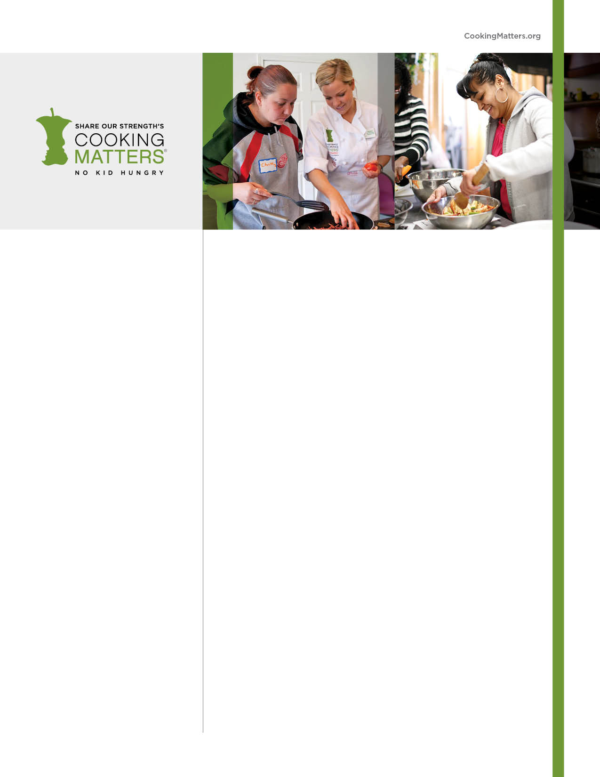

COOKING MATTERS

Learn to cook healthy meals for   
your family

* Cook nutritious and delicious food on a budget
* Get a free bag of groceries each week
* Discuss nutrition concepts and work with a chef to prepare healthy meals
* Take a trip to the grocery store to learn to shop for healthy and affordable food
* Meet your neighbors in class and share ideas for making small changes toward a healthier life

This program was partially funded by USDA’s Supplemental Nutrition Program as part of SNAP-Ed, brought to you by Cooking Matters®. To find out more, contact 1-866-950-FOOD(3663).

**SIGN UP FOR A FREE COOKING CLASS!**

**DATES: Every Thursday**

**March 24th-May 5th**

**No classes April 21st.**

**TIME:** 6:00-8:00pm

**LOCATION:**

Charlesview Community Center

123 Antwerp St. Brighton, MA 02135

**RSVP:**

Alicia Castro

617-208-1562

