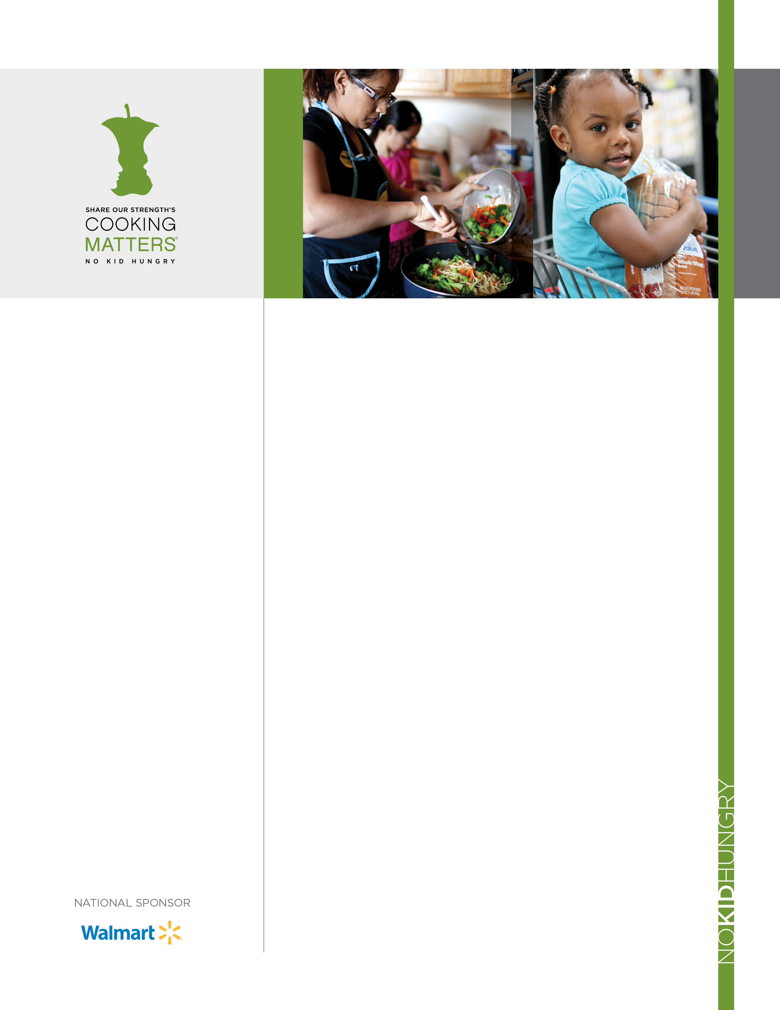­­

CookingMatters.org

**FREE Healthy shopping Workshop!**

**Join us for healthy snacks, shopping tips, and get a $10 gift card for healthy groceries!**

* Find healthiest options
* Get best value for fruits and vegetables
* Compare unit prices to find bargains
* Understand food labels
* Find whole grains in labels, and Stick to your budget!

**After the workshop you will receive:**

|  |  |  |
| --- | --- | --- |
| **C:\Users\jmaillet\AppData\Local\Temp\icon_2386.png**  **$10 Gift card to supermarket!** | ***C:\Users\jmaillet\Desktop\icon_34909.png***  **Book full of healthy recipes & shopping tips!** | **C:\Users\jmaillet\AppData\Local\Temp\icon_22894.png**  **Free reusable grocery bag!** |
|  |  |  |



.

**SIGN UP TODAY FOR A FREE Workshop!**

**Date: Friday, March 11, 2016**

**Time:** **1:00-2:30PM**

**Location:**

**Charles River**

**Community Health**

**564 Main street Waltham Ma, 02452**

**RSVP:** **Berlineda Pierre**

**781-693-3826**

